Jihun Kim

Jeffrey Ringer

English 355

6 December 2023

**Public-Facing Project Draft 2**

**Introduction**

In this public-facing project draft, I organized and analyzed the responses to the Google form conducted as part of the project. Using the data analyzed, I confirm the public's perception of ChatGPT's writing and lay the foundation for talking about how ChatGPT can help writing.

**Usage**

The usage section of the webpage shows how people use or do not use GenAI in their writing through graphs based on the responses of the Google form. I created some helpful graphs from the responses and displayed them on the website along with the analysis of the graphs.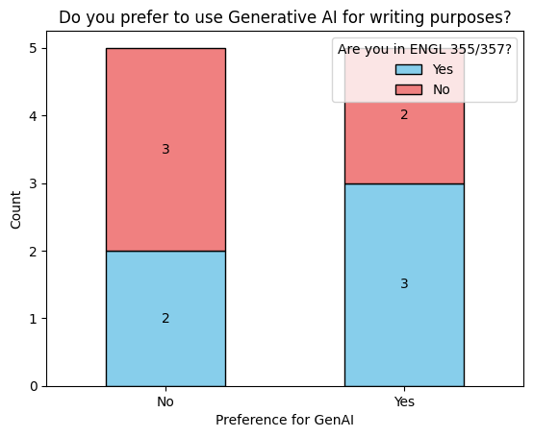

5 out of 10 people who responded to the survey prefer to use ChatGPT for writing.

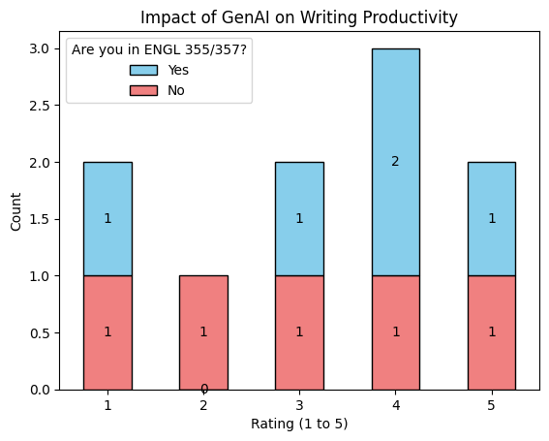

The metric by which people think GenAI impacted their writing is roughly evenly distributed. The average score was 3.2. People who prefer to use GenAI tend to think that GenAI will have a significant impact on their writing, while people who do not prefer to use GenAI tend to believe that GenAI will not have much of an impact on their writing.

The primary reasons for people using GenAI in their writing are:

* To get a general idea or word references,
* To find synonyms and think of different ways to phrase sentences, and
* To get an assist of grammar or form

The primary reasons for people NOT using GenAI in their writing are:

* Preferring certain writing styles,
* Difficult to get it to work the way they want,
* No desire to use it, and
* Do not want to rely on it.

The reasons for using or not using GenAI in their writing show that people who use GenAI for writing want to get general ideas or benefit from it as an auxiliary writing tool, such as selecting words or phrases. Meanwhile, people who don't use GenAI for writing either don't need help from GenAI or aren't satisfied with its performance.

**Perception**

The perception section of the webpage shows the challenges or limitations of using GenAI and how many people can match the writer of the text correctly.

Typical reasons why people are reluctant to use ChatGPT include Word Choice, Difficulty of writing prompts, and poor results of ChatGPT. Respondents pointed out that ChatGPT sometimes provides non-professional vocabulary while it sometimes provides too formal words. Also, ChatGPT is not good at matching the tone as well. Writing a prompt to ask ChatGPT needs to be specific because ChatGPT does not fully understand the prompt. Also, giving repetitive answers was one of the reasons why people avoid using ChatGPT in their writing.

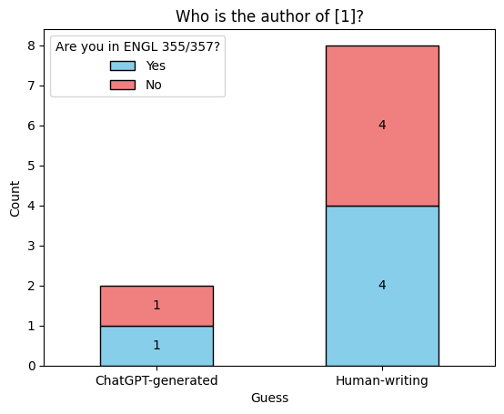

This text was designed to see how much help ChatGPT can provide when writing informative text such as research reports, especially when writing abstracts. The correct answer rate for the first problem was 20%, the lowest among the four problems. It shows that a good prompt can help ChatGPT produce quality writing.

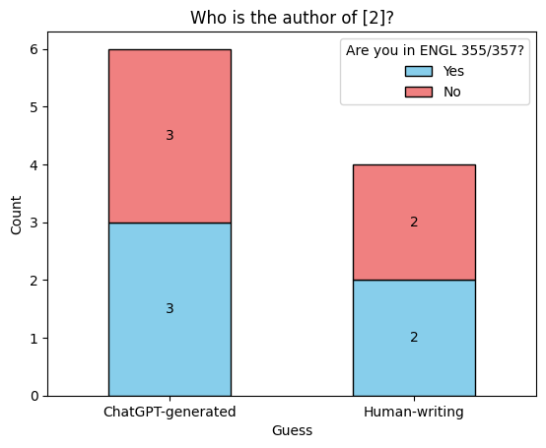

This text sought to determine whether readers could determine narrative text written in an unfamiliar way was human-written. Unfamiliar sentences caused unnaturalness, which led only 40% of people to believe that the text was written by a person.

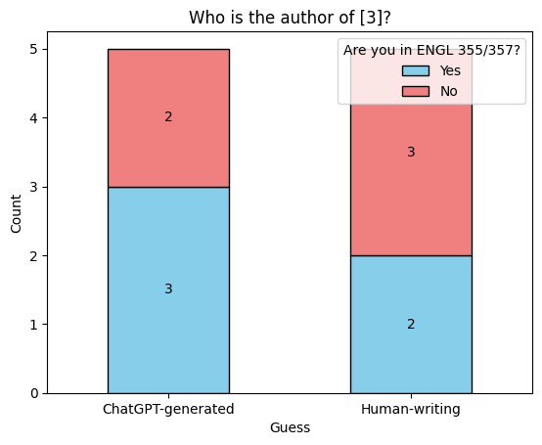

This text was written by a person and is quoted in the sense that it takes the form of a general essay. Although 50% of respondents identified that this post was written by a human, the remaining 50% guessed that it was generated by ChatGPT based on the unnaturalness of the text.

Texts [2] and [3] show that even if the writing is written by a person, from the reader's perspective, if the sentence connection is awkward or the choice of words is strange, it makes readers feel the text is written by ChatGPT.

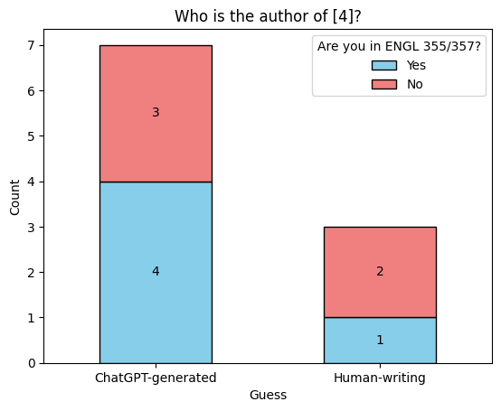

This text was written to understand how much ChatGPT can help people write their essays. I asked ChatGPT to write a 100-word essay on the topic of the Civil War, and it was quite well structured. However, 70% of people who noticed some of the unnaturalness of this post successfully guessed that it was written by ChatGPT. It reveals that ChatGPT may still be lacking in writing texts such as essays.

When creating the Google form, I wanted to see whether students who were more familiar with narrative text through ENGL 355/357 courses would show better results, but it didn't seem to make a big difference.

After four quizzes to guess the author of the article, I asked each respondent to explain why they made that decision. People consider determining the writer using vocabulary, tone, format, sentence structure, and point of view of the text. People think ChatGPT uses more descriptive words, creative flow, creative narration, choppy or changed direction, and boring texts. Also, people expect human writers to use smooth flow and using the good structure of introduction, elaboration, and conclusion.

**After Draft 2**

I will discuss more about the challenges or limitations of using GenAI and ChatGPT’s writing assistance power. Through four questions to distinguish between ChatGPT and human-writing, some points can prove why peoples’ thoughts of ChatGPT could be wrong. I can talk about ChatGPT’s word choice and the difficulties of prompts. If needed, I will use the analysis of the [text from the Analyzing AI project](https://chat.openai.com/share/02d38f32-cac8-4902-84a1-cad680a6e0f3).